FACT user guide

Importing images for FACT analysis
- Before beginning, make sure you have a version of Mathematica installed on your computer. Additionally, it is useful to have FIJI (an ImageJ distribution).
- To begin a FACT analysis for a new dataset, first go into FACT\Fibril width analysis\Data files. Copy and paste the template folder, and rename it. In this example, we renamed it MyNewSEMimages.
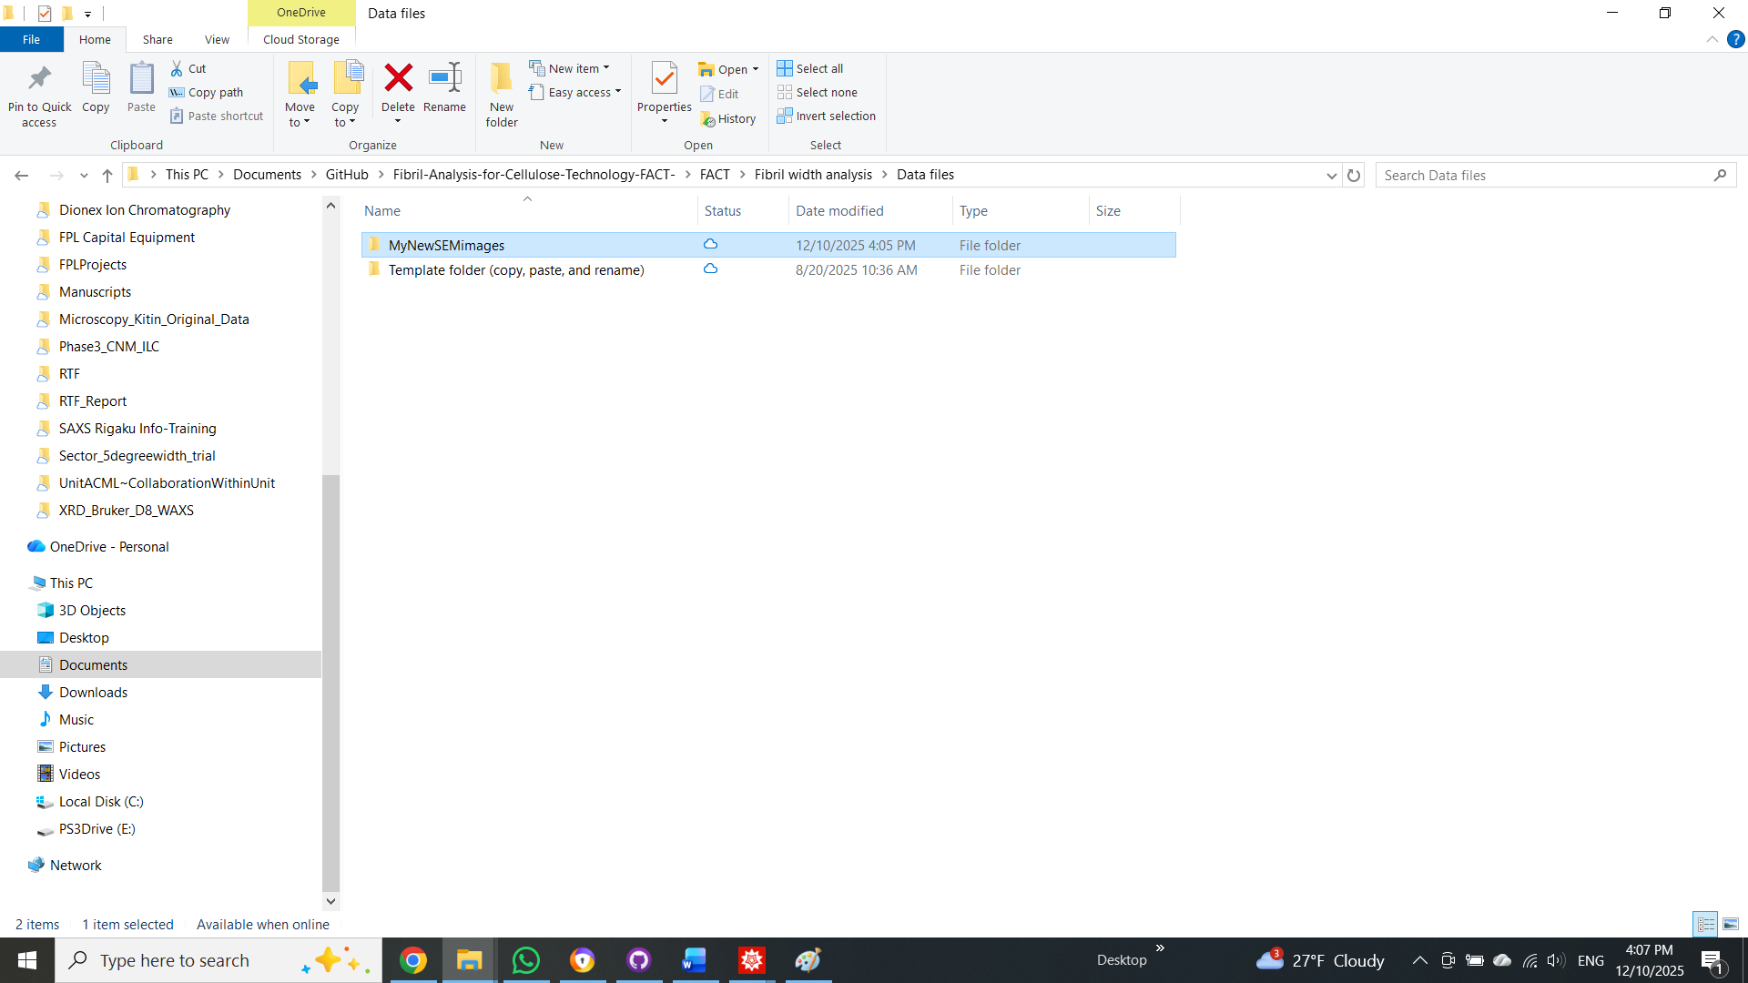

- Next, add the images intended for this dataset into FACT\Fibril width analysis\Data files\MyNewSEMimages\Original images. Open a new file explorer window and go to FACT\Fibril width analysis\Parameter files. Then, copy and paste the parameter file template and rename it to match the data file name. Then double-click MyNewSEMimages parameter file to open this Mathematica notebook.
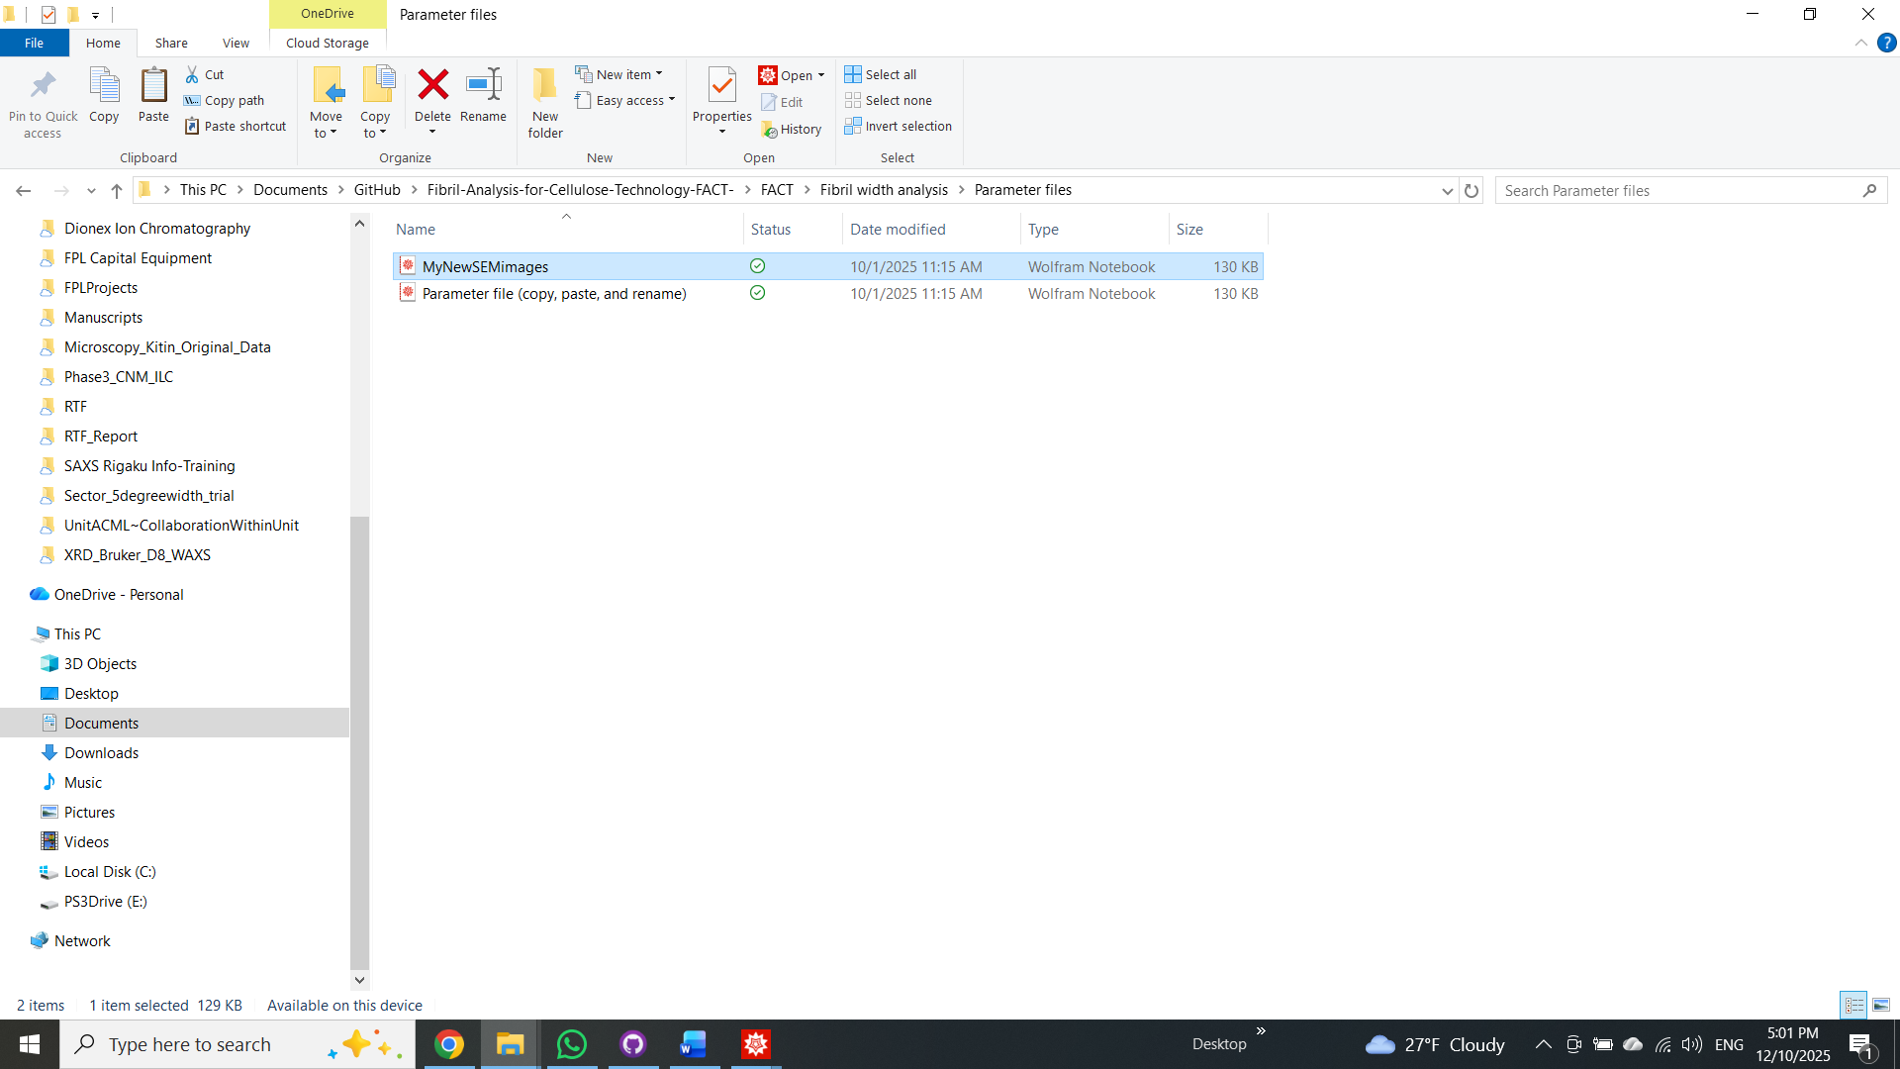

- Go to FACT\Fibril width analysis and open FiberWidth_FrontEnd. Set both windows side by side. We suggest placing the FrontEnd window on the left and the parameter file on the right.

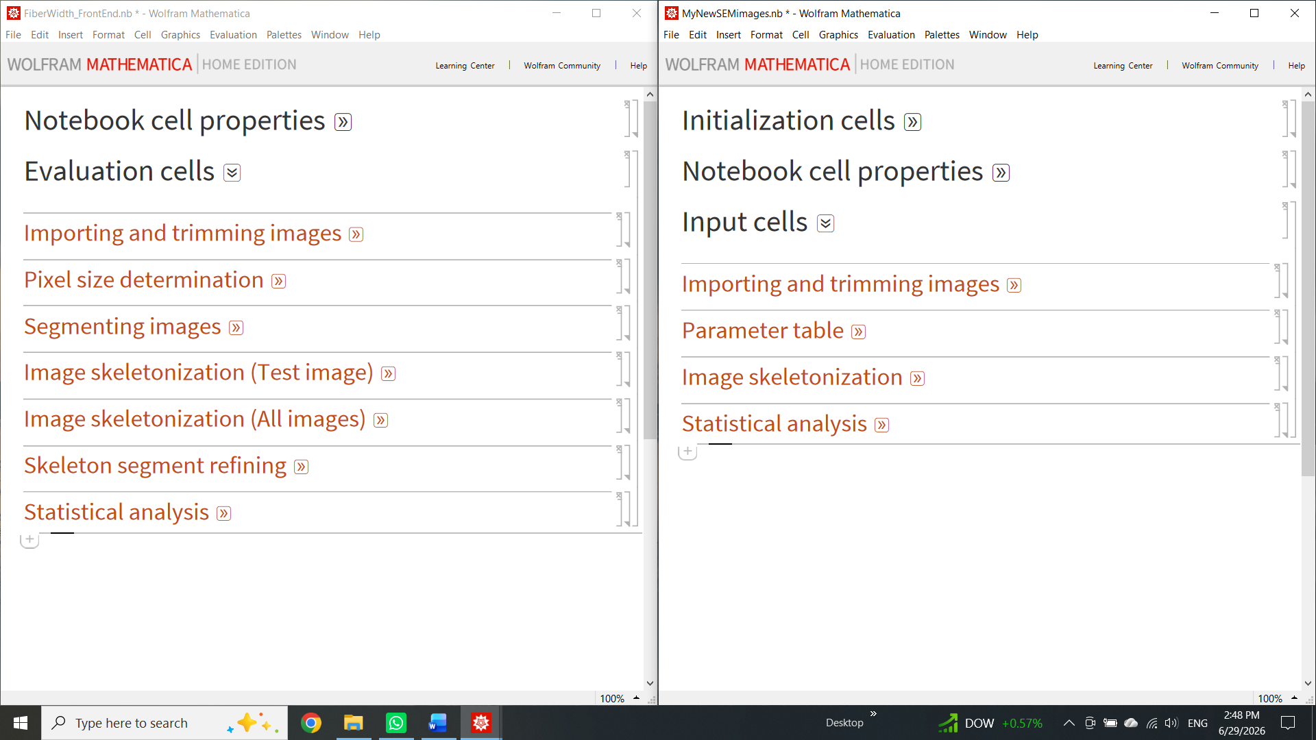

- Now we can see how the fibril width analysis section of FACT is split into subsections in the Mathematica notebook. As the name implies, the parameter file stores all the parameters the user selects to process the images in this dataset. The user will work sequentially through these notebooks to analyze their dataset. First, we will import the original images. For this, open the Importing and trimming original images tab in both FrontEnd and the parameter file by clicking the double arrow next to the section title. Write the name of the dataset file you wish to analyze in the variable datafn located in the parameter file. In this case, it will look like $datafn="MyNewSEMimages";$. Whenever the input needs to be a string, use quotation marks. To evaluate this line of code, first click within that line to place the cursor and press Shift+Enter. Then, evaluate all lines (going one by one) in the Import section of the FrontEnd. If the name entered in the variable datafn matches the dataset folder name, you should see the list of imported images in the FrontEnd. Always input parameters and evaluate the parameter file section before evaluating its corresponding FrontEnd section.

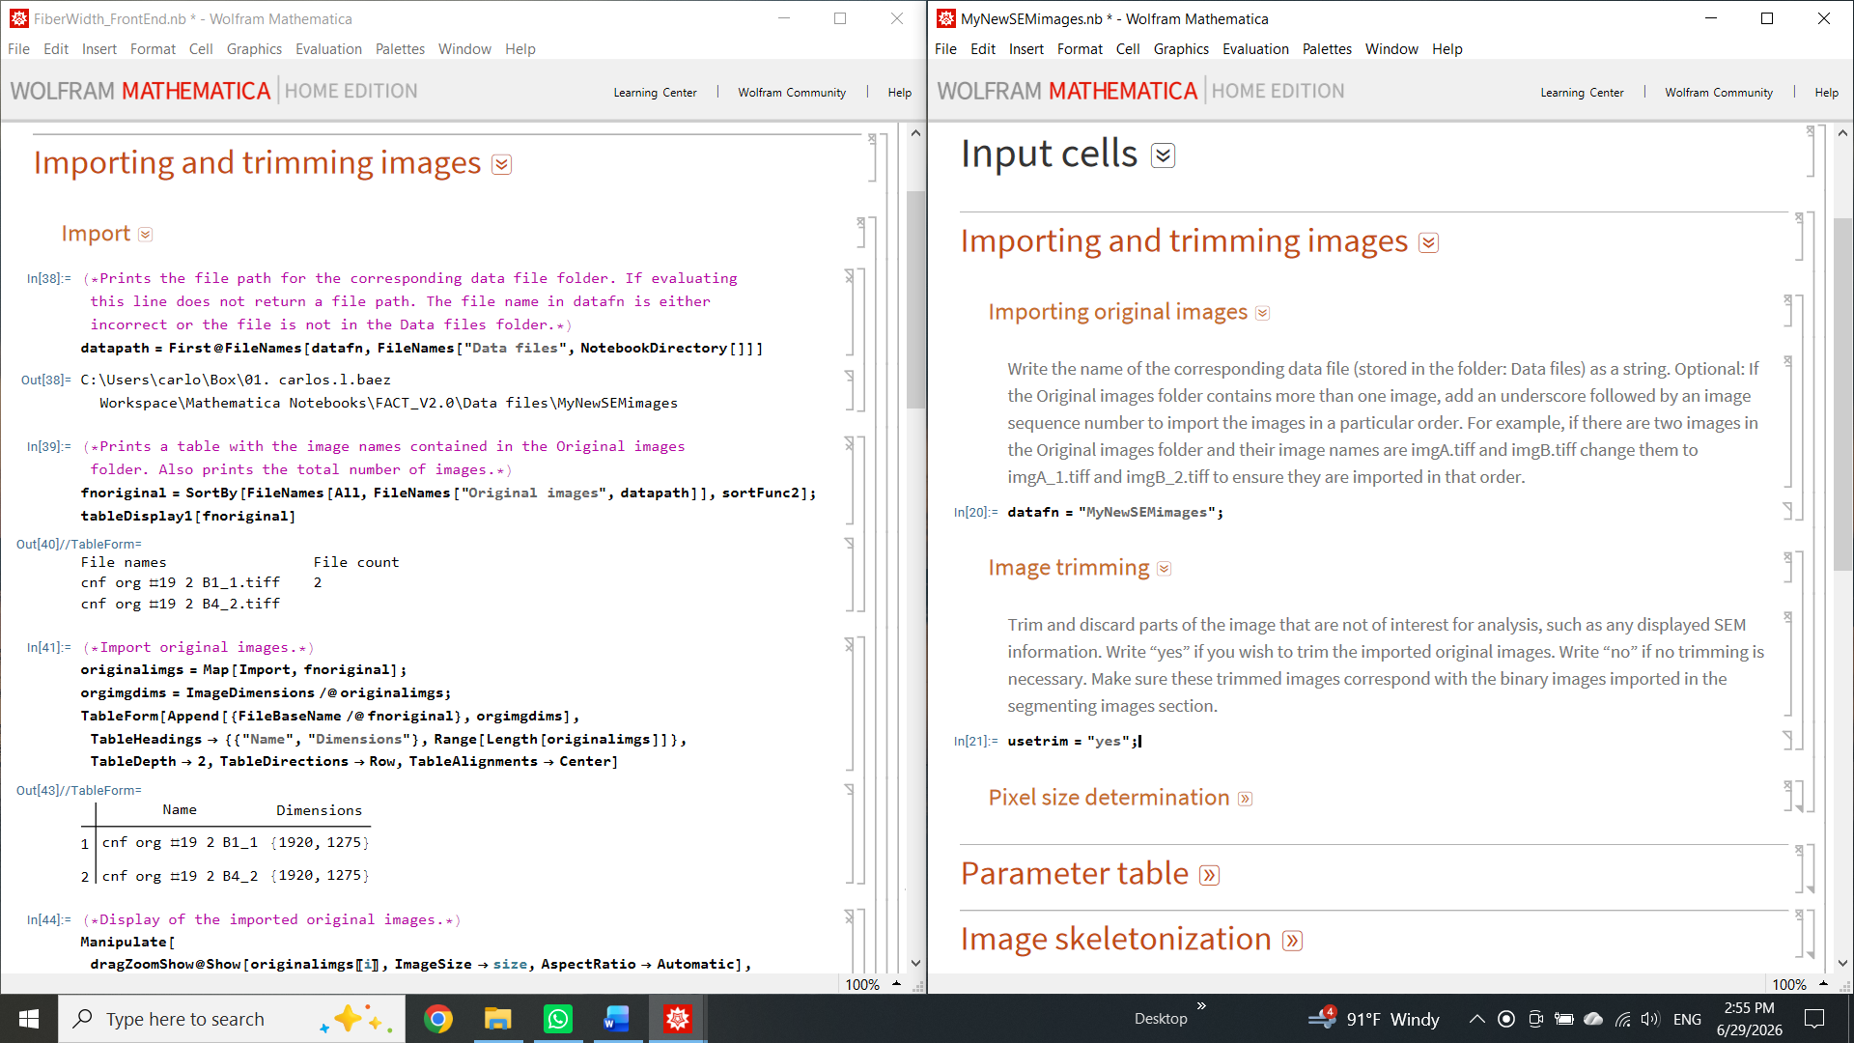

Introducing the parameter table
- The parameter table records the analysis metadata. Here, the user enters all required values that affect the fibril-width analysis. To begin, starting at the fourth row, edit the table so that the number of indexed rows matches the number of imported images. Depending on the current number of indexed rows, you may need to add or delete rows to accomplish this. To add rows, place the cursor in the last row and press Ctrl + Enter. Repeat until the number of indexed rows (index numbers entered manually) equals the number of images. To delete rows, highlight the full rows to be deleted and press the delete button (Del) on the keyboard. In this example, because we imported two images, only two indexed rows are necessary.
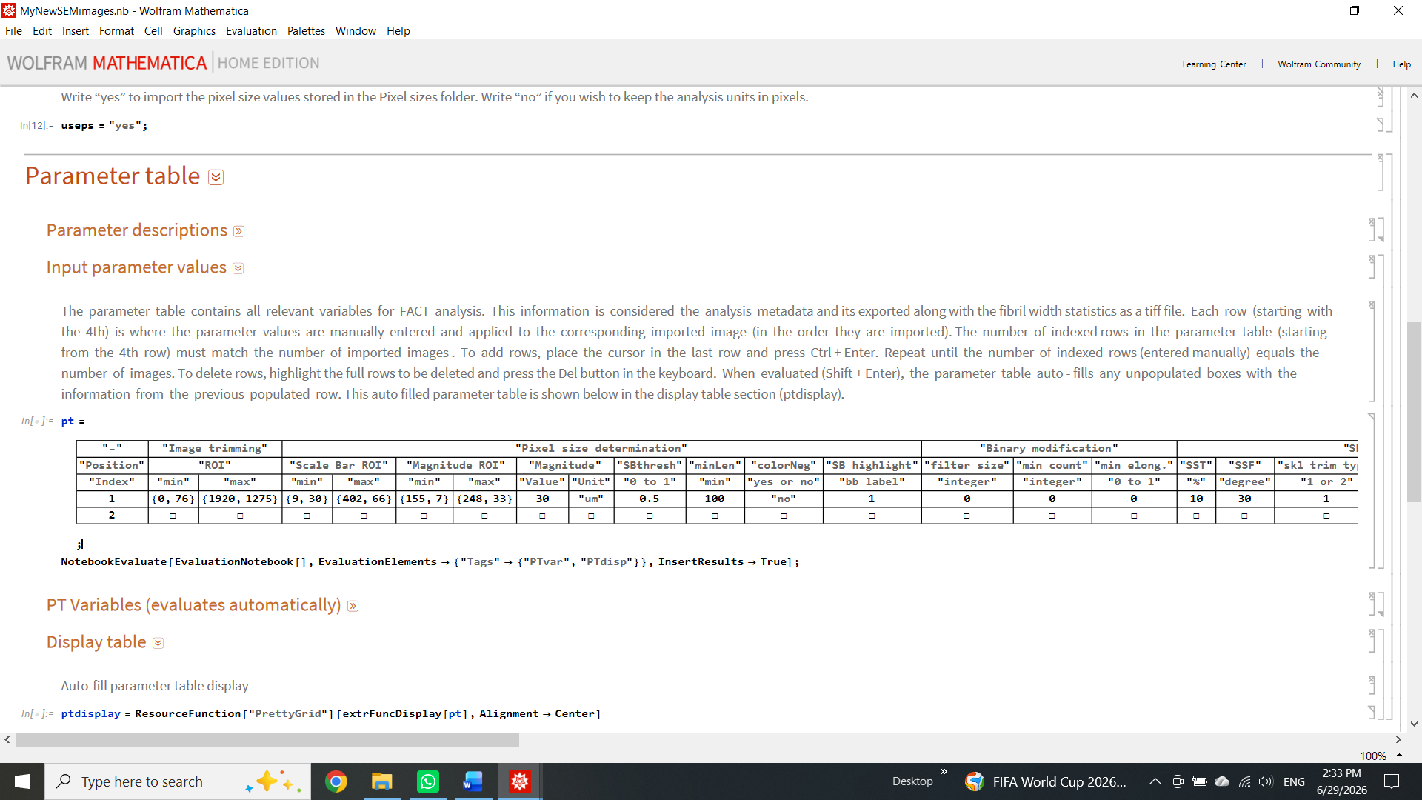
When evaluated (Shift + Enter), the parameter table auto-fills any unpopulated boxes with the information from the previous populated row. The auto-filled parameter table is shown in the display table section as ptdisplay.

Selecting image ROI
- Next, we will trim the original images to remove the SEM information at the bottom. This new trimmed image only contains the region of interest for fibril-width analysis. First, open the image trim subtab and enter $usetrim="yes";$. Evaluate this line (Shift + Enter). Then, to determine the trimming dimensions, hover over the original image display in the FrontEnd, right-click, and select Get Coordinates. The original image display supports drag-zoom, letting you zoom into the area of interest. Here, we aim to determine a region of interest (ROI), that is, a minimum and maximum {x, y} coordinate set that contains only the wanted parts of the image while excluding the SEM information area.
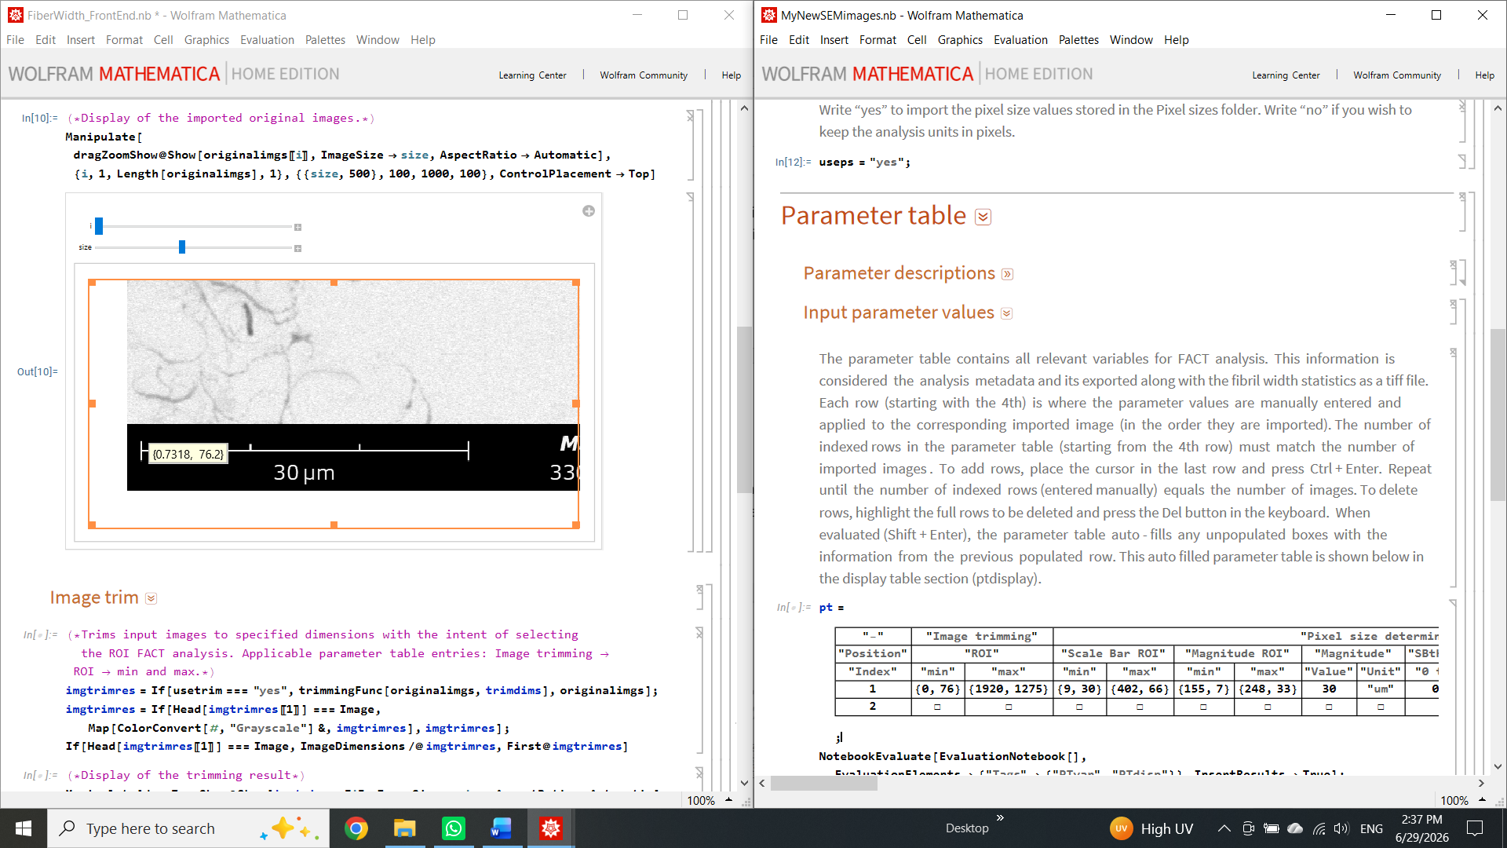

Within the Parameter table section, go to the Input parameter values subsection, and under image trimming, add the min and max ROI coordinates as highlighted below.


In this case, since both imported images have the same dimensions, we only need to add the information in the first indexed row, as the second row will be autofilled (only seen in the display table ptdisplay) with the same values after evaluating the parameter table. Evaluate the parameter table, then evaluate imgtrimres, and display the result. If satisfied with the results, export the trimmed images by evaluating the line in the export trimmed images subsection. The trimmed images will be automatically saved in FACT\Fibril width analysis\Data files\MyNewSEMimages\Result file\Trimmed images.

Calculating pixel size
- In this next section, we will use the scale bar length and the scale bar magnitude in the original SEM image to compute the pixel size. First, go back to the original image display and drag-zoom into the scale bar region. Right-click and select Get Coordinates to find the minimum and maximum {x,y} coordinates that encapsulate only the scalebar ROI. Make sure to leave a small amount of background padding around the scale bar so that the entire scale bar is within the ROI. Enter these numbers in the parameter table under scale bar ROI. Then, evaluate scalebarimg in the FrontEnd. Only the scale bar of each image should be visible in this result. If this is not the case, adjust the ROI values and reevaluate.
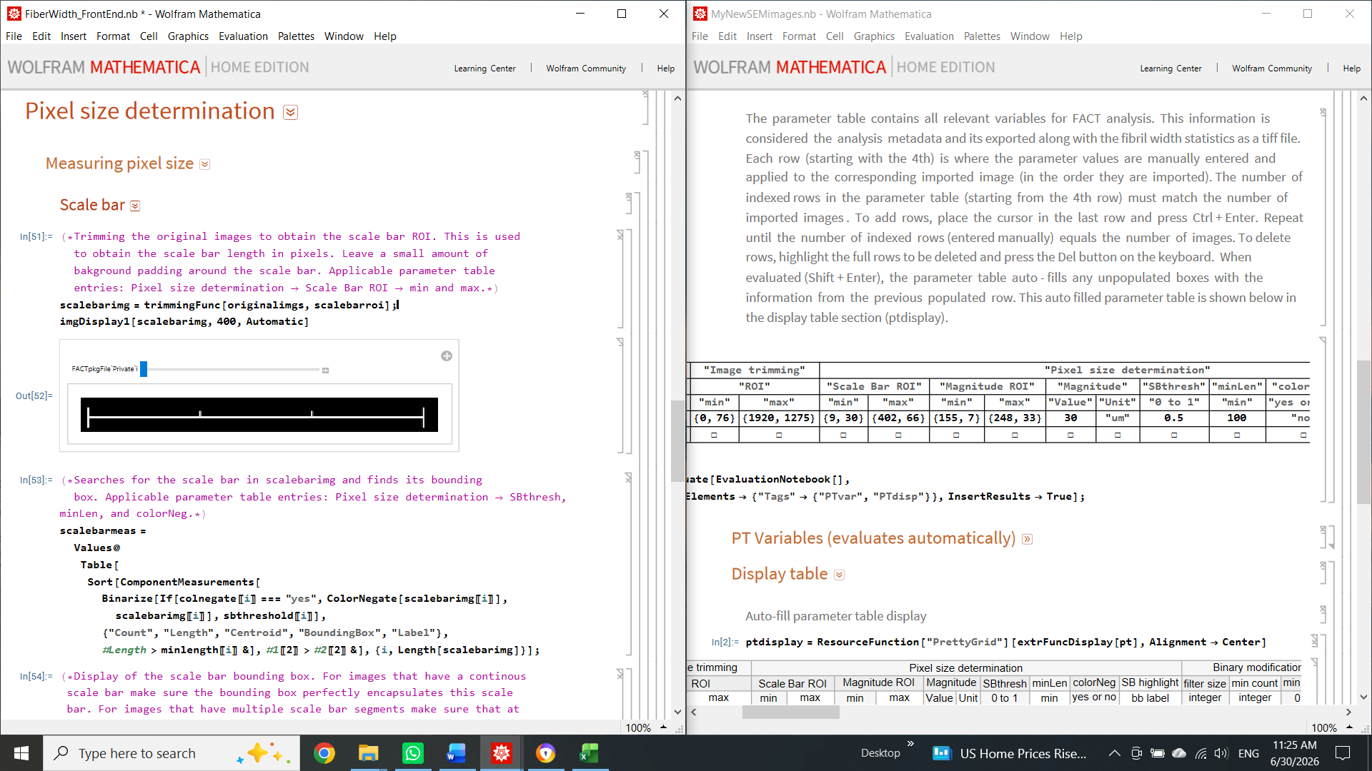

- Next, to detect the scale bar as a single object, the scale bar image will be binarized using a gray-level threshold. Here, the applicable parameters are SBthresh, minLen, and colorNeg as highlighted below. Evaluate scalebarmeas then scalebarhighlight in the FrontEnd. The identified components will be encased in a red translucent bounding box. If this is not the case, the previous parameters may need to be adjusted. Each bounding box has an associated index. If the scale bar is a continuous line, it should have one identifying index (shown in scalebarhighlight in Cyan). Enter this value into the SB highlight column in the parameter table. If the scale bar is split into multiple segments, each segment should have its corresponding identifying index. For this case, enter the indices of the first and last segments, formatted as {first index, last index}, in the SB highlight column. Finish by evaluating the line pixelcount to determine the length of the scale bar in pixels.

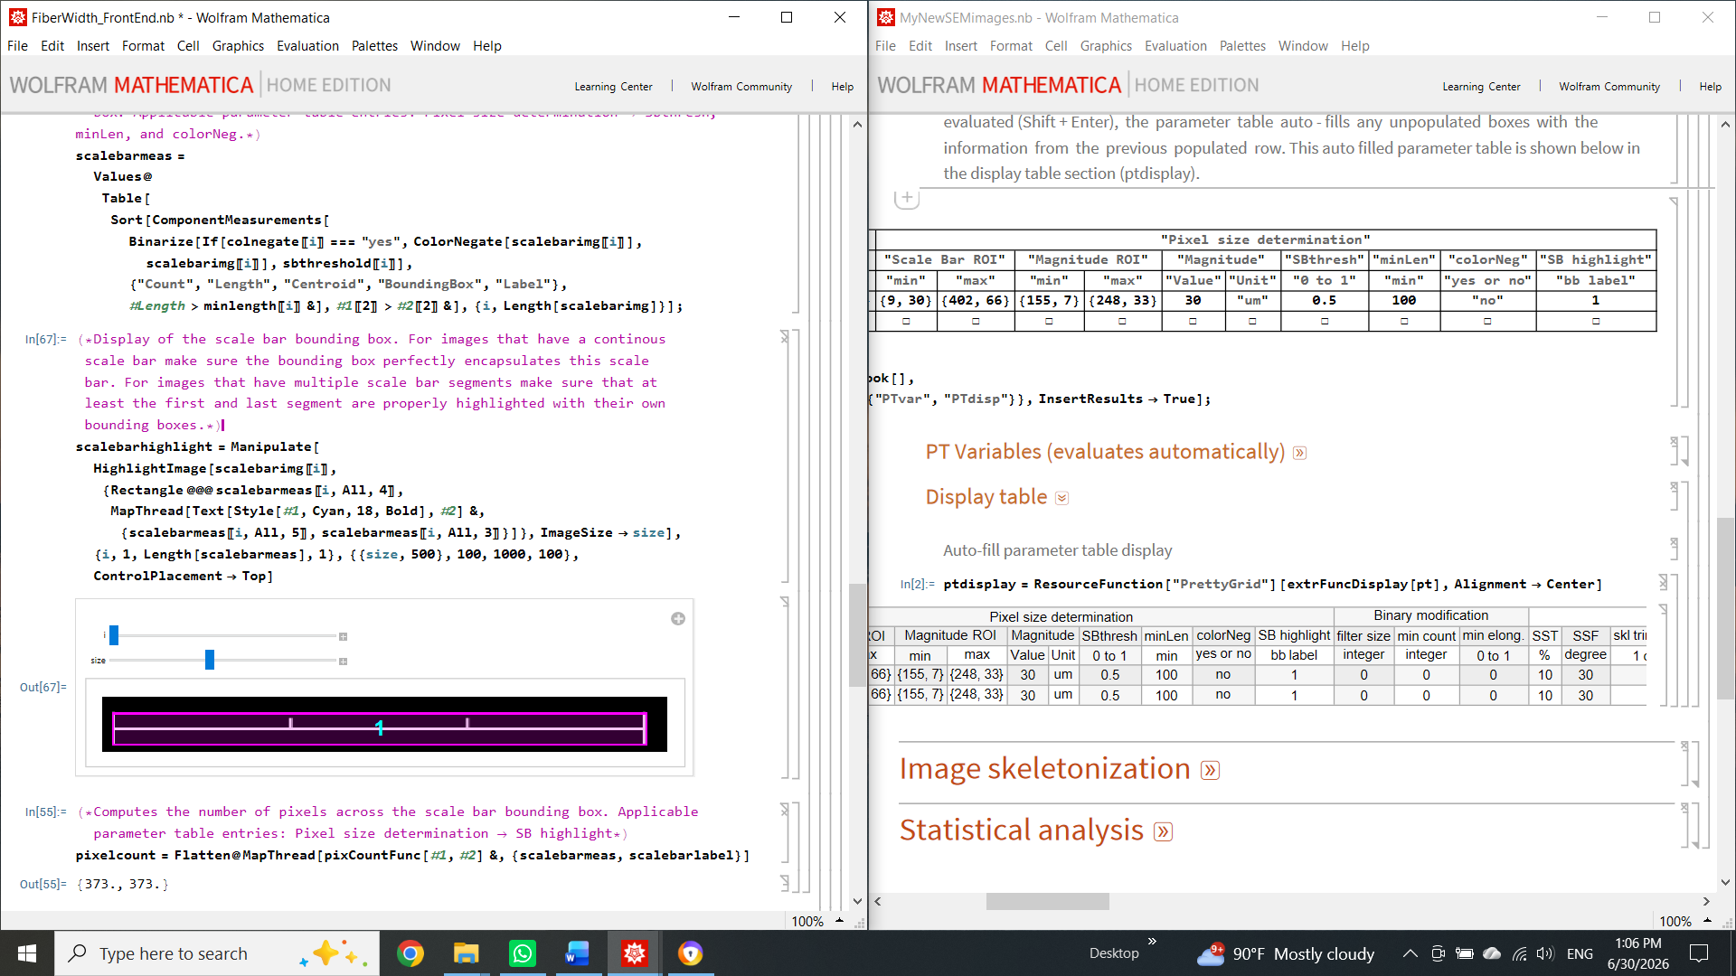

- Now we need to enter the scalebar's magnitude. Following the same procedure as before, determine the ROI coordinates that only contain the scalebar magnitude. Enter these values in the parameter table in the Magnitude ROI column as well as the magnitude value and unit in the Magnitude column. Use the included visualization tool to compare and ensure that the user-input scale bar's magnitude value and unit match the image's magnitude and unit. If this is the case, evaluate the last couple of lines of this subsection to compute the pixel size for each image and export this information.
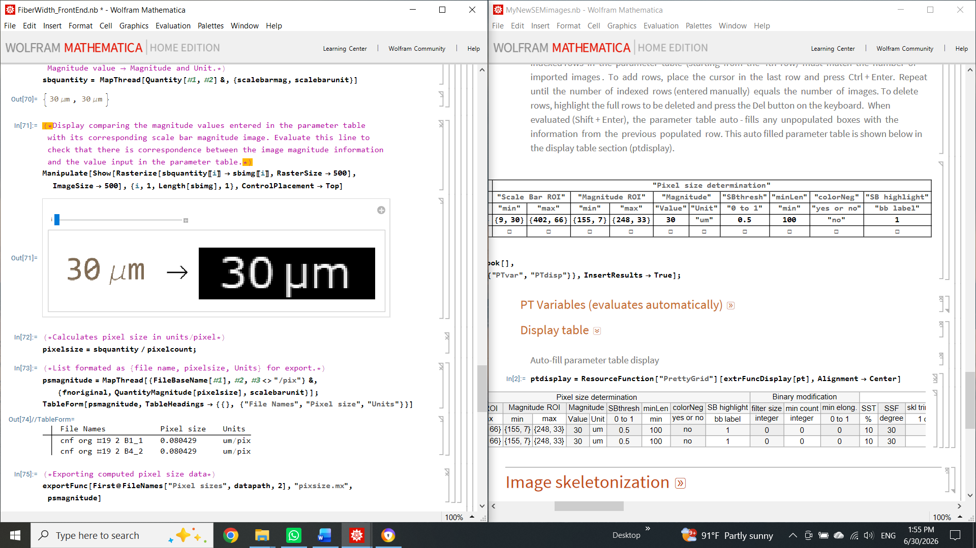

Image segmentation
- The next step in the FACT analysis is to acquire an adequate binary segmentation of the imported images. Here, we aim to classify pixels into white foreground (cellulose nanofibrils, CNFs) and black background (substrate or other unwanted particles). The time and effort required for this step depend on the complexity of the images. If the image has sufficient contrast between the background and foreground, a simple histogram-based gray-value threshold would suffice for segmentation. Otherwise, a trained convolutional neural network (CNN) can be used for this task. A CNN trained on various Negative contrast SEM images is included in FACT. The user can use this trained network to segment the previously obtained and exported trimmed images.
- FACT can be used to train a new CNN by either continuing to train a pretrained CNN or starting from an untrained CNN. Additionally, the user can create new training images from their own dataset and add them to the preexisting training set. For now, we will continue this guide by using a pretrained CNN. The latest version of this CNN is labeled CNFNegcSEM_U2Net_230R_V4.
- First, at the top of the Mathematica notebook, go to Cell – Delete all output – then save and close both the parameter file and the FiberWidth_FrontEnd.
- Then, go to FACT\U^2-Net Segmentation\Parameter files. Copy and paste the template parameter file, then rename and open it. Then go back to FACT\U^2-Net Segmentation and open U^2-Net_FrontEnd
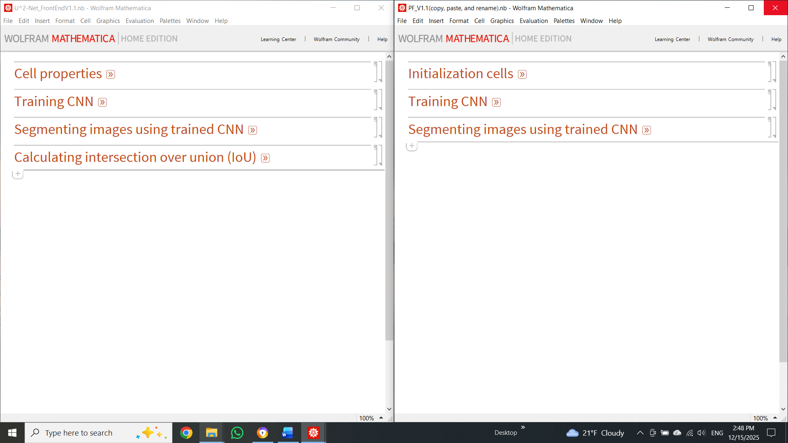

- For now, we are only interested in using a previously trained CNN for image segmentation. Therefore, we will start by opening the Segmenting images using trained CNN tab in both the parameter file and the front-end. First, add the file path to the trained CNN. The simplest way to do this is to find the trained CNN in your file explorer window and copy it (Ctrl+C). The trained CNN should be stored in: FACT\U^2-Net Segmentation\Trained U^2-Net. Then, place your cursor after trainedpath= in the parameter file and paste (Ctrl+V). Mathematica will add the complete path directory to that line. Then add the path to the folder containing the trimmed SEM images intended for segmentation. Here, the user can add multiple folder paths containing trimmed SEM images. In this example, we only added one folder path to imagepaths.
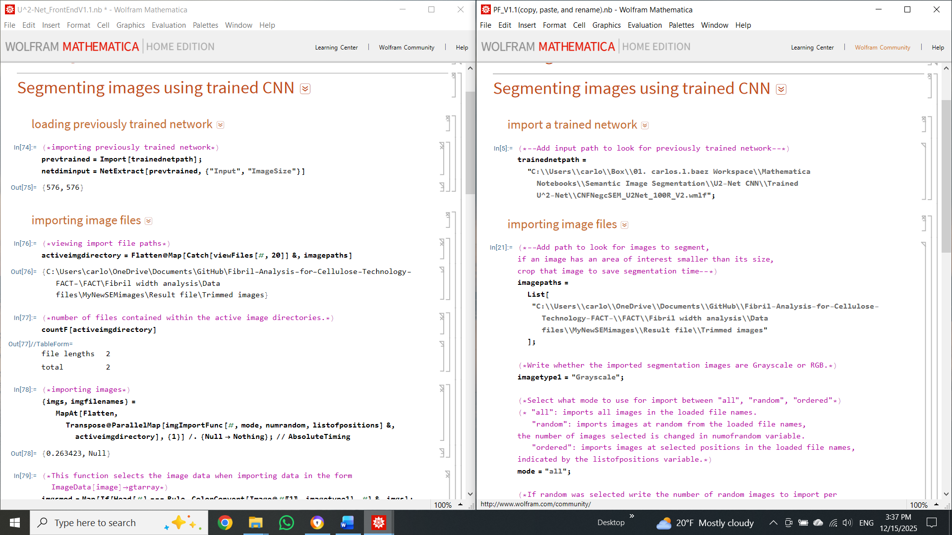

- Evaluate the parameters in this section, then load the CNN and import the image files by evaluating the corresponding section in the front-end. To begin image segmentation, segment a test image to ensure everything is working correctly. If so, segment all imported images by evaluating all lines in the next section. Assess the segmentation quality using the included visualization tools. If the segmentation quality is satisfactory, export all images in the next section. To export, copy and paste the file path into ouputdirectory in the parameter file. In this case, we export the segmentation results to: FACT\Fibril width analysis\Datafiles\MyNewSEMimages\Segmented images.
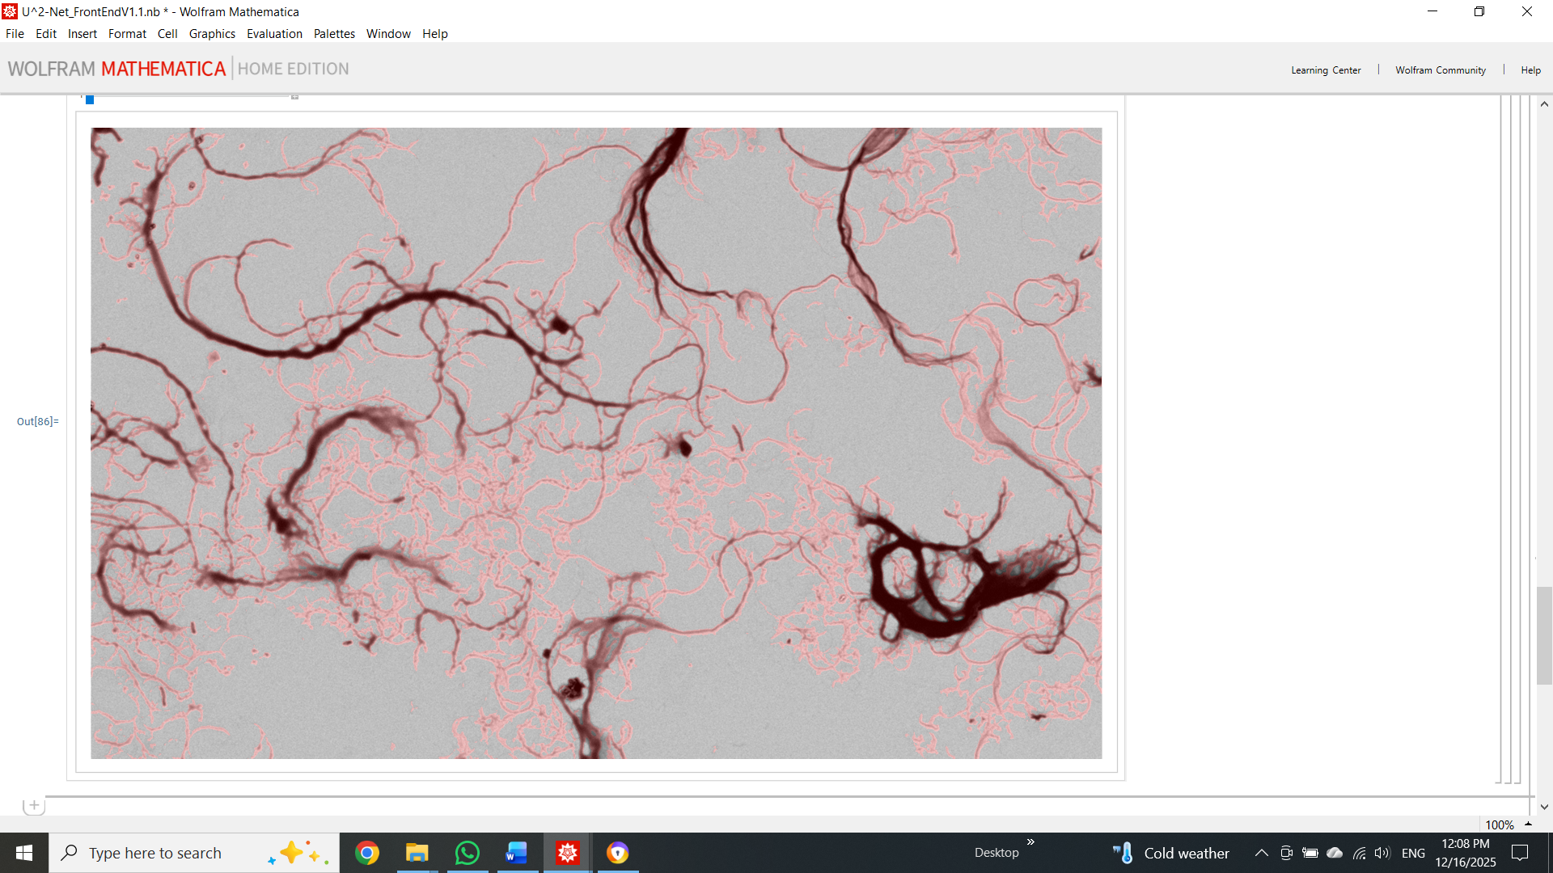
- If the segmentation is not satisfactory, new training images from the current dataset will need to be generated, and the CNN retrained. For FACT analysis, we suggest using the Weka plugin in ImageJ to generate new training images. Jump to section Training CNN to learn how to create training images using Weka.

Image skeletonization
- After exporting the image segmentation results, save and close all Mathematica notebooks. Then, go back to the Fibril width analysis folder and reopen the FiberWidth_FrontEnd and the parameter file MyNewSEMimages. Evaluate the parameter file, then from the FrontEnd evaluate the following:
Importing and trimming original images – all lines from the Import and Image trim subsections
Pixel size determination – all lines from the pixel size data select subsection
Segmenting images – all lines from Importing CNN segmented images
Next, to test the method, we can skeletonize a selected test image and view the result. Evaluate the functions located in Image skeletonization (Test image) and Visualizations 1. Here, you can visualize how the skeletonization appears before any refining.
- To continue, evaluate all lines from the section named Image skeletonization (All images). Here, the binary images can first be modified by applying a Gaussian filter, followed by filtering based on shape and size. The Gaussian kernel size can be set to 0 to forgo this filter. In this section, the user can select to filter out individual particles using a minimum count and/or minimum component elongation filter. Set these parameters to 0 to forgo these filters. Below, the corresponding parameters are highlighted in the parameter table. Finish by evaluating skeletonization subsection and exporting the skeletonization results.
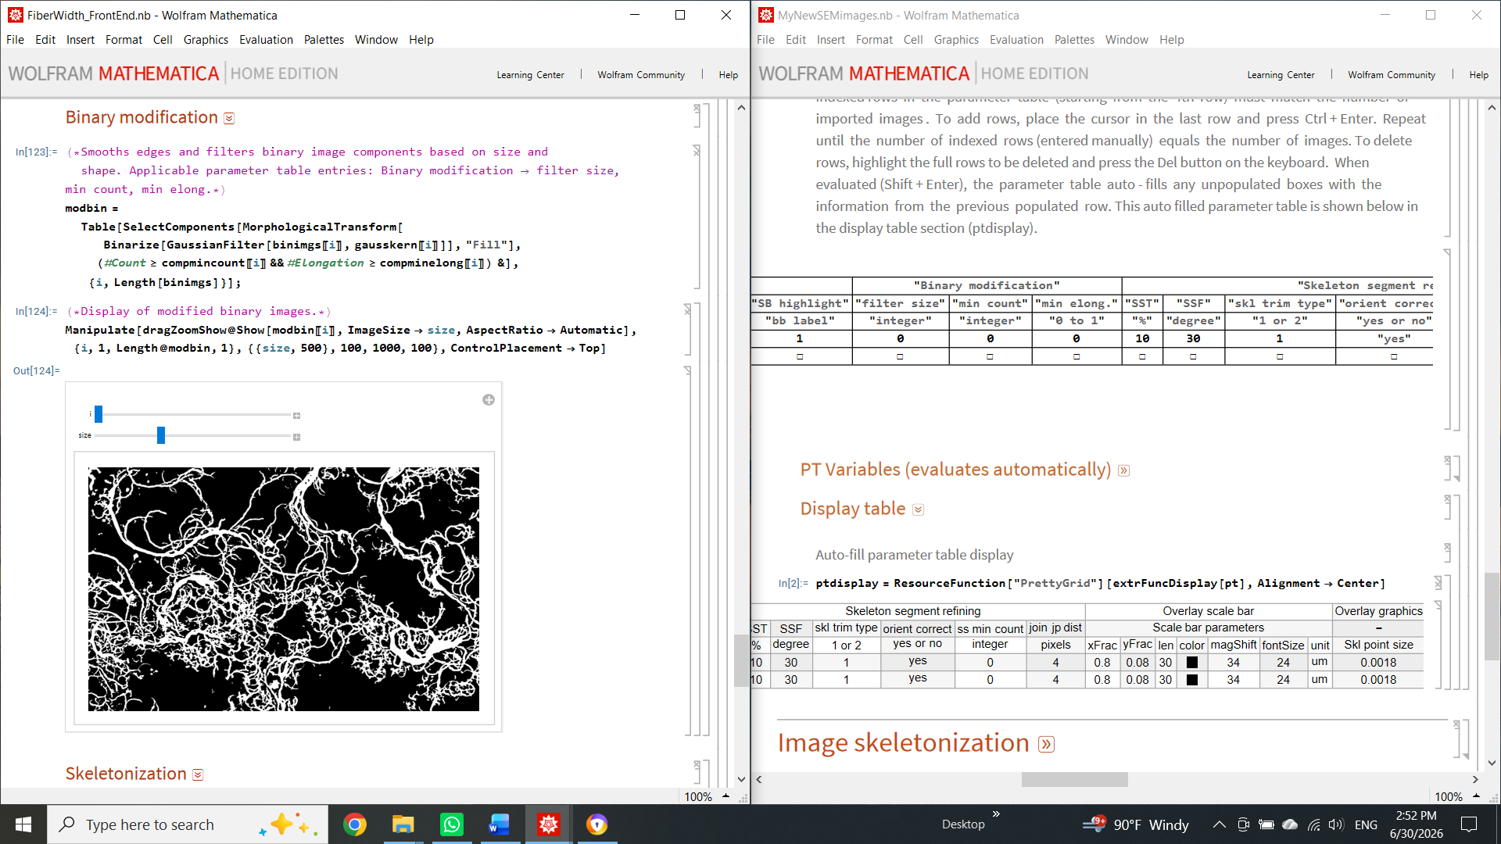

Skeleton segment refining
- The next step is to refine the skeleton network. Here, the intent is first to partition, then to trim and remove unwanted skeleton segments from the width analysis. We are only interested in including the skeleton segments that align with fibril centerlines. First, evaluate all lines from the Skeleton partitioning and measurements section to partition the skeleton network into individual skeleton segments, and extract the coordinates of these segments.
- To begin the skeleton segment refinement, in the parameter table under SST, enter a value. We recommend a number between 0 and 40. This value represents the percentage of points on each skeleton segment that will be removed from the ends. SST stands for skeleton segment trimming. Skeleton ends near junction points tend not to follow the fiber centerline. Trimming these ends helps reduce that unwanted contribution. Additionally, the user can select whether to trim only from the skeleton segment side adjacent to an endpoint (skl trim type = 1), i.e., only from the junction point side or both sides (skl trim type = 2).
- Next, enter an SSF angle (practical values between 5 and 60 deg) in the parameter table to remove all skeleton segments from the analysis whose average distance transform rate of change exceeds the SSF angle. SSF stands for skeleton segment filtering. Skeleton segments resulting from a jagged-edge artifact tend to have high SSF angles. The lower the angle entered, the more skeleton segments will be removed. Additionally, small skeleton segments can be removed by entering a threshold size in ss min count.

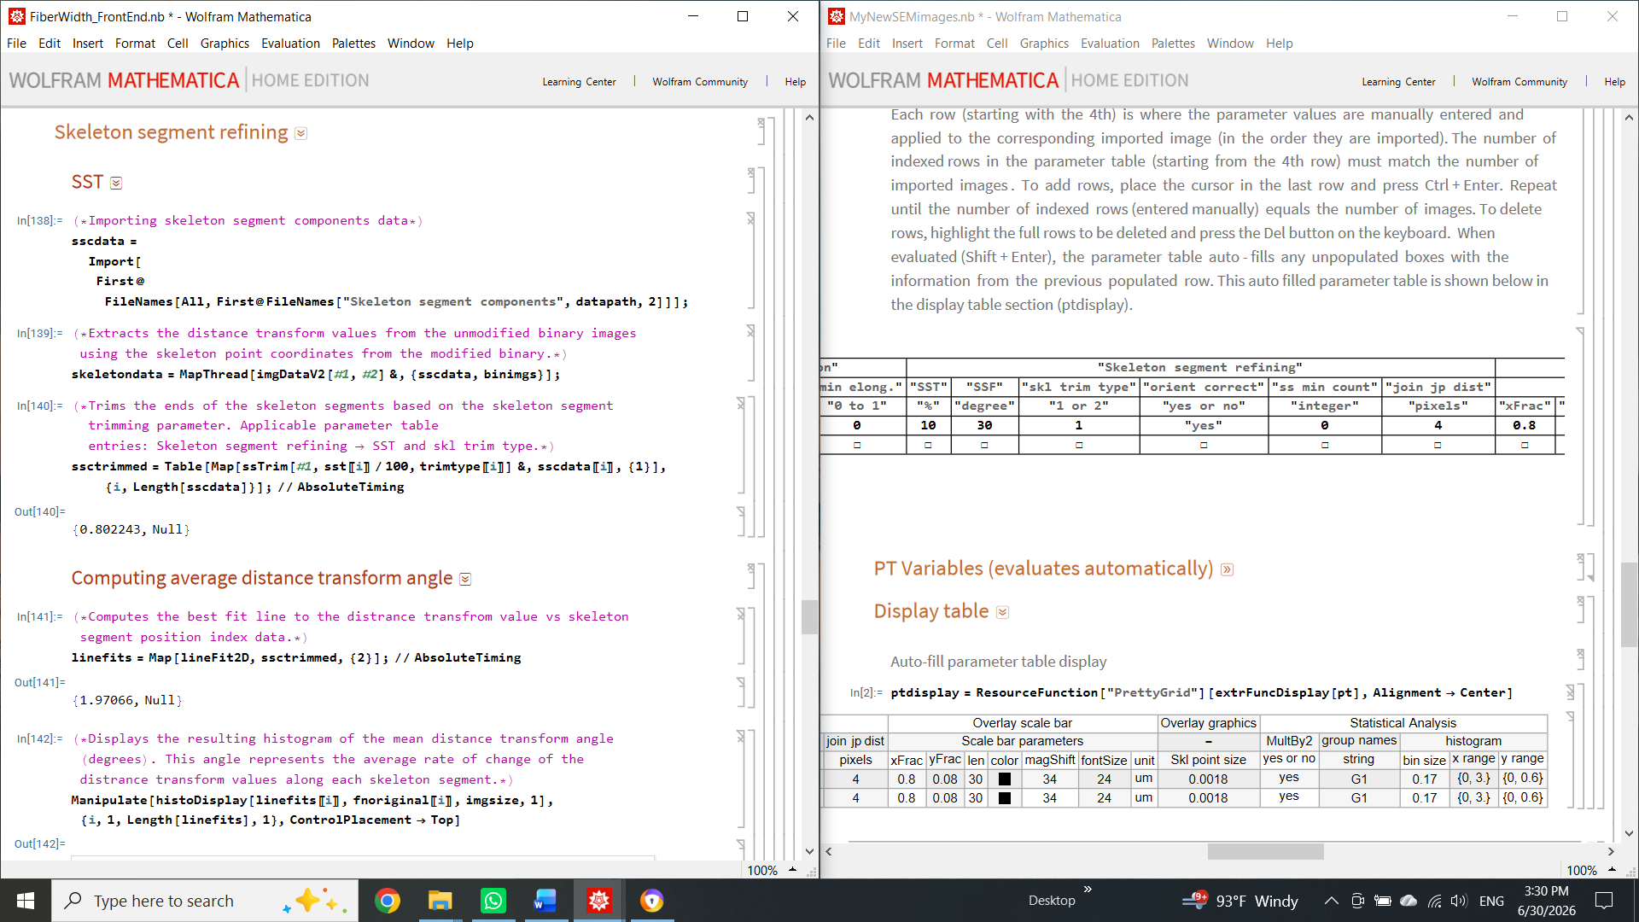

- In the FrontEnd, evaluate the lines in the skeleton segment refining section. The user needs to exercise judgment and, by trial and error, visually determine which values remove mostly unwanted skeleton segments while keeping those that follow fibril centerlines. Users are encouraged to use the included visualization tools to help determine whether the current refining parameters are acceptable. One such tool is the average distance transform rate-of-change color map. This color map shows the average rate of change of the distance transform for each skeleton segment. This map helps the user select an appropriate SSF angle to filter out unwanted skeleton segments.

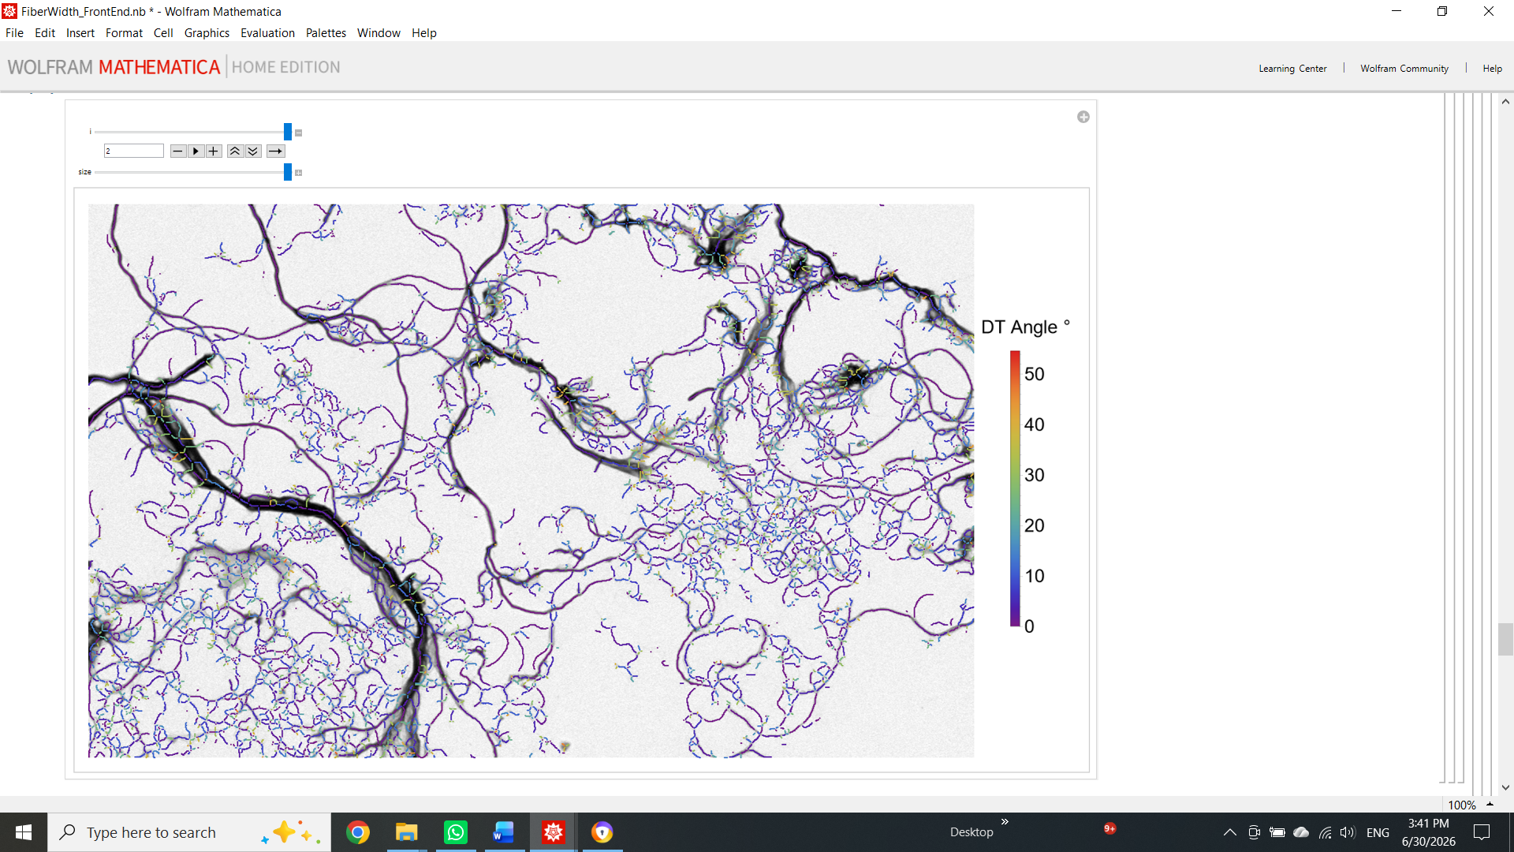
- Once all lines are evaluated in the skeleton segment refining section, go to the sub-section Visualizations 2 to visualize the skeleton refining results as an overlay image with and without a scale bar. In addition, this section allows the creation of a junction points overlay and a width-color map. If desired, finish by exporting these overlay images.

Fibril width statistical analysis
- In the parameter table, enter the applicable values into the parameter as shown below:
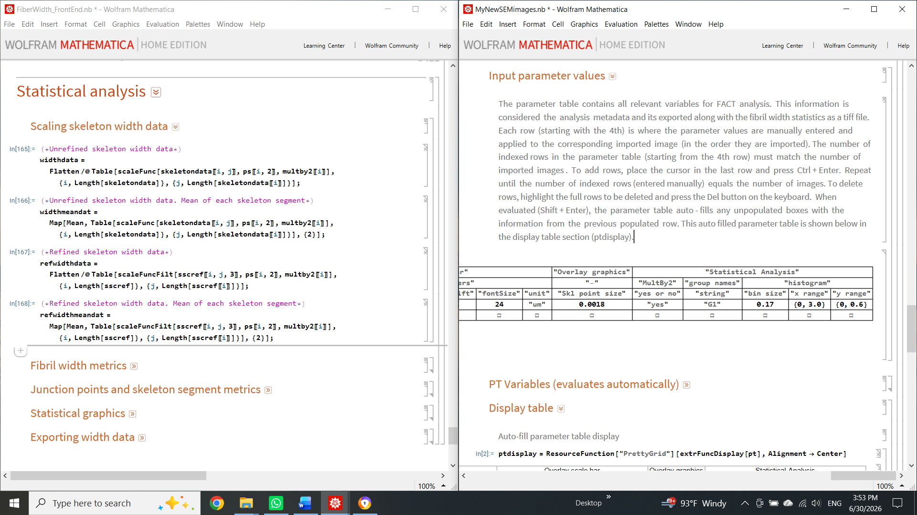

- To finish the FACT analysis, evaluate all lines in the Statistical analysis section. In the parameter file, the user can choose from several options for grouping and visualizing fiber-width statistical data. The resulting fiber width data can be exported as xlsx, csv, JSON, or txt for plotting in other software or for subsequent analysis.
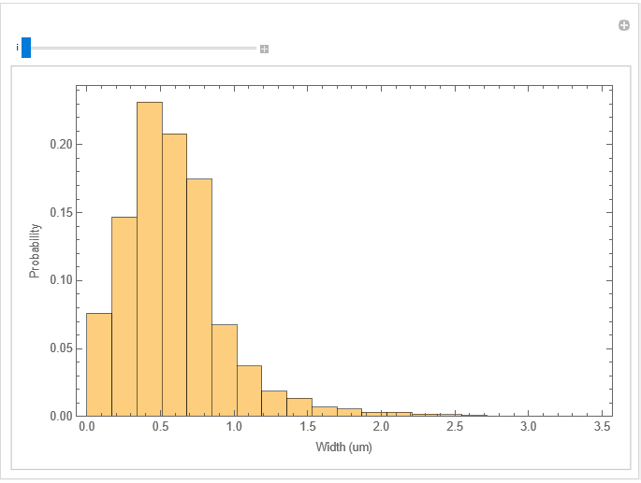

Training CNN
- CNN training may be necessary if the segmentation results are not satisfactory. To train the U^2-Net CNN, the user must first create new training images. Here, we will use Weka, a FIJI plugin that allows the user to assign classes to different regions of the image using the included FIJI drawing tools. Weka uses the user-provided pixel classifications as input and trains a machine learning model to generate a class-probability map of the current image. The default machine learning model in Weka is a random forest.
- To begin, go to FACT\U^2-Net Segmentation\Training sets, then copy, paste, and rename the template folder. Here, we named the new folder "New data set." Open this new folder and add the trimmed SEM images you wish to use for training to the target images folder.
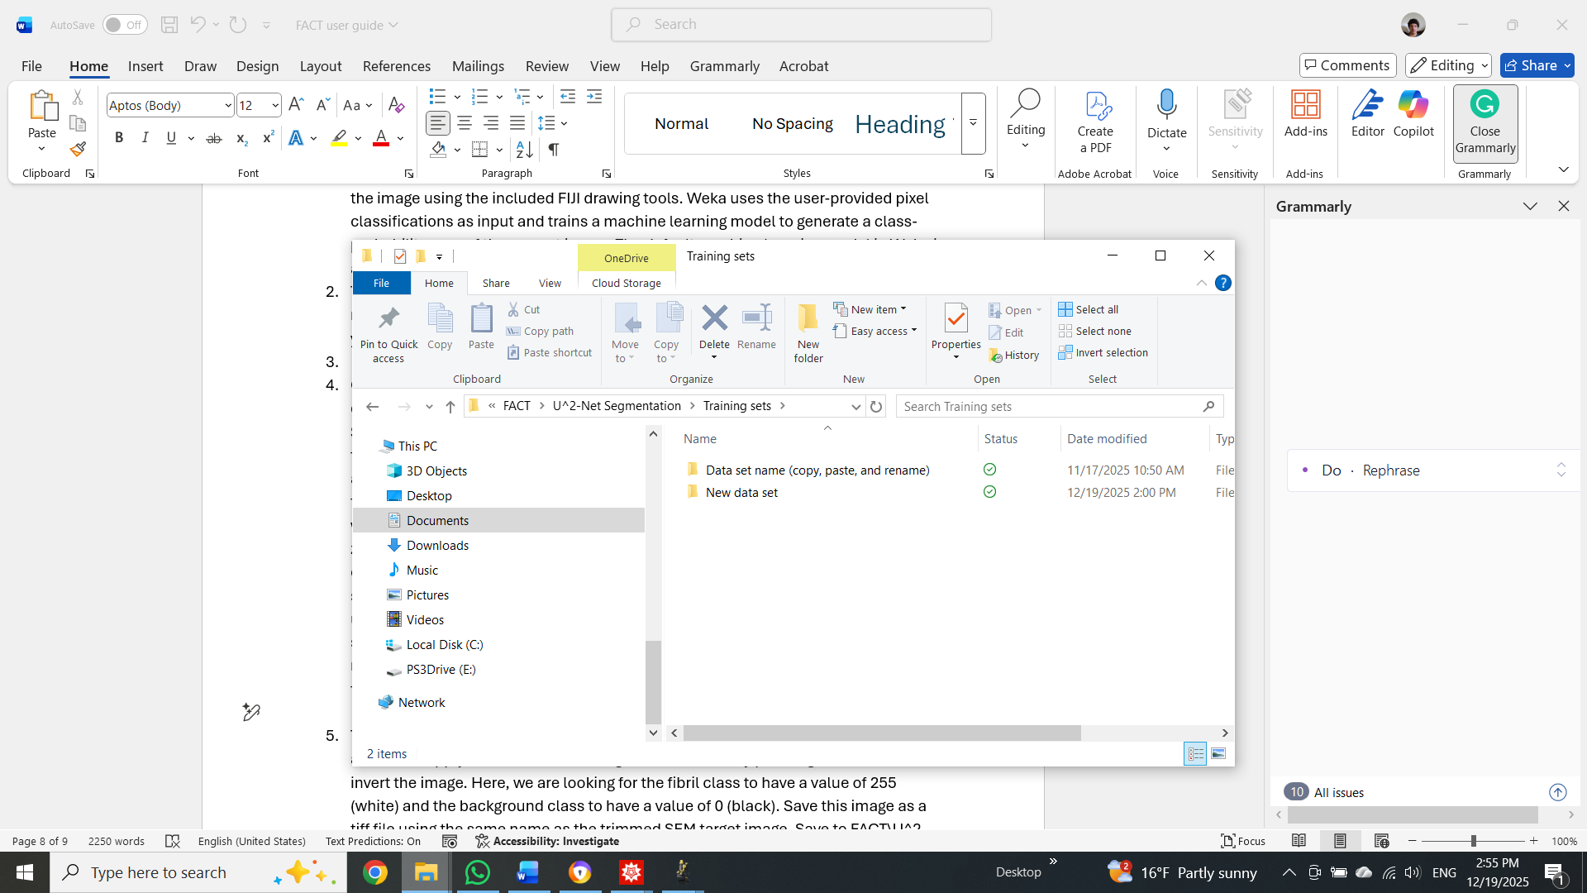

- Open FIJI, then select the first target image you wish to work with by dragging and dropping it into the FIJI interface. Next, in the FIJI menu, go to Plugins -> Segmentation -> Trainable Weka segmentation. Use the drawing tools to paint the fibril regions and add them to class1. Similarly, paint the background regions and add them to class2. We suggest using the freehand drawing tool: right-click the Line tool and select Freehand line. Then, double-click the Freehand line tool and set the width to 1 pixel for maximum control over pixel selection. Use the zoom-in (+) and zoom-out (-) keys to help select pixels. Once there are about 5 to 10 entries per class, press the 'train classifier' button. Once the model finishes training, it will show you an update on its performance by overlaying the segmentation result. The user needs to determine whether more training data is necessary. If so, keep selecting more class examples for each class until, after training the model, the segmentation is satisfactory. The number of examples needed to achieve good results typically ranges from 10 to 30 per class, depending on the image's complexity.

- To export the segmentation result, click Create result, then Ctrl+Shift+T, click auto, then click apply, to threshold the image values. Finish by pressing Ctrl+Shift+I to invert the image. Here, we are looking for the fibril class to have a value of 255 (white) and the background class to have a value of 0 (black). Save this image as a TIFF file using the same name as its corresponding trimmed SEM target image. Save to FACT\U^2-Net Segmentation\Training sets\New data set\ground truth images.
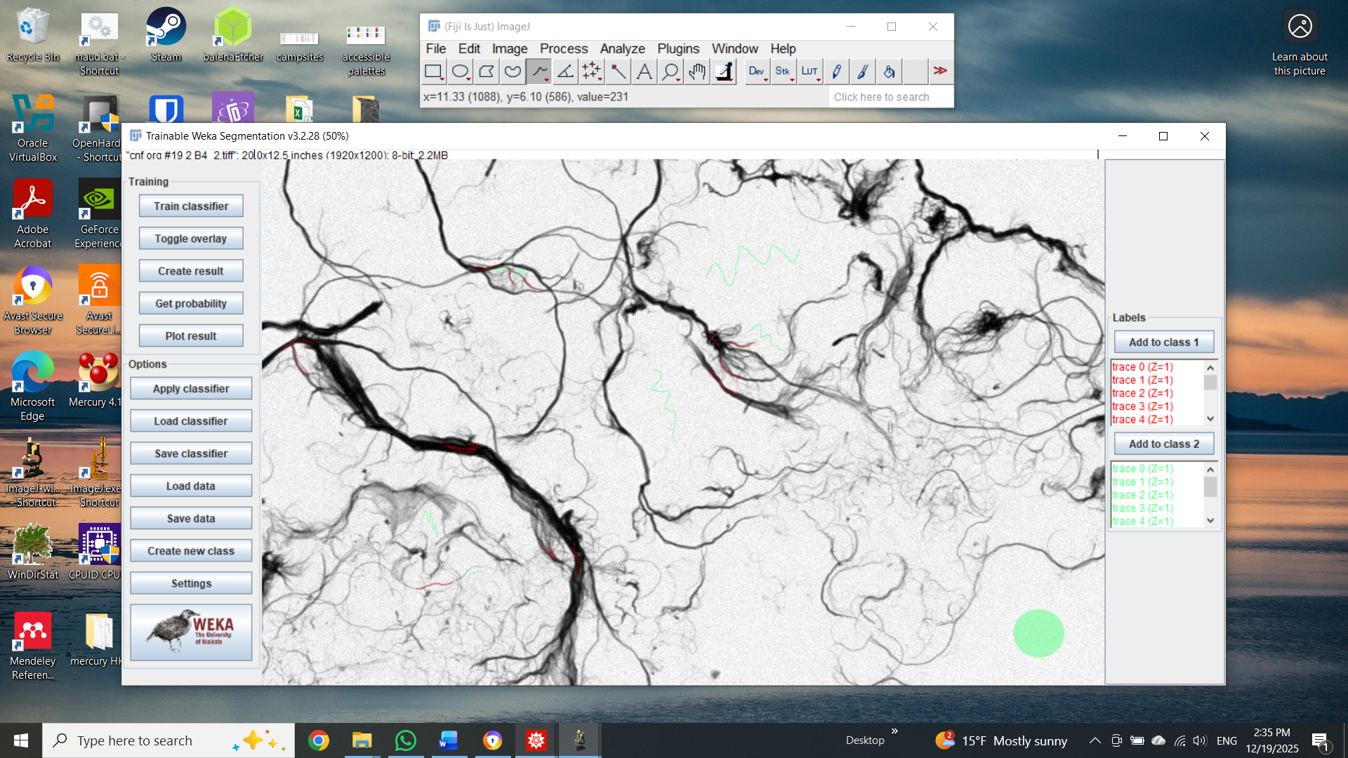

- Here is an example of the resulting binary image. This image can now be included in the U^2-Net training set. Repeat the process for the remaining images in the target images folder and close FIJI.

- Next, go to FACT\U^2-Net Segmentation and open U^2-Net_FrontEnd and the corresponding parameter file. Open the Training CNN - import paths, add the paths into trainingdatasets as shown: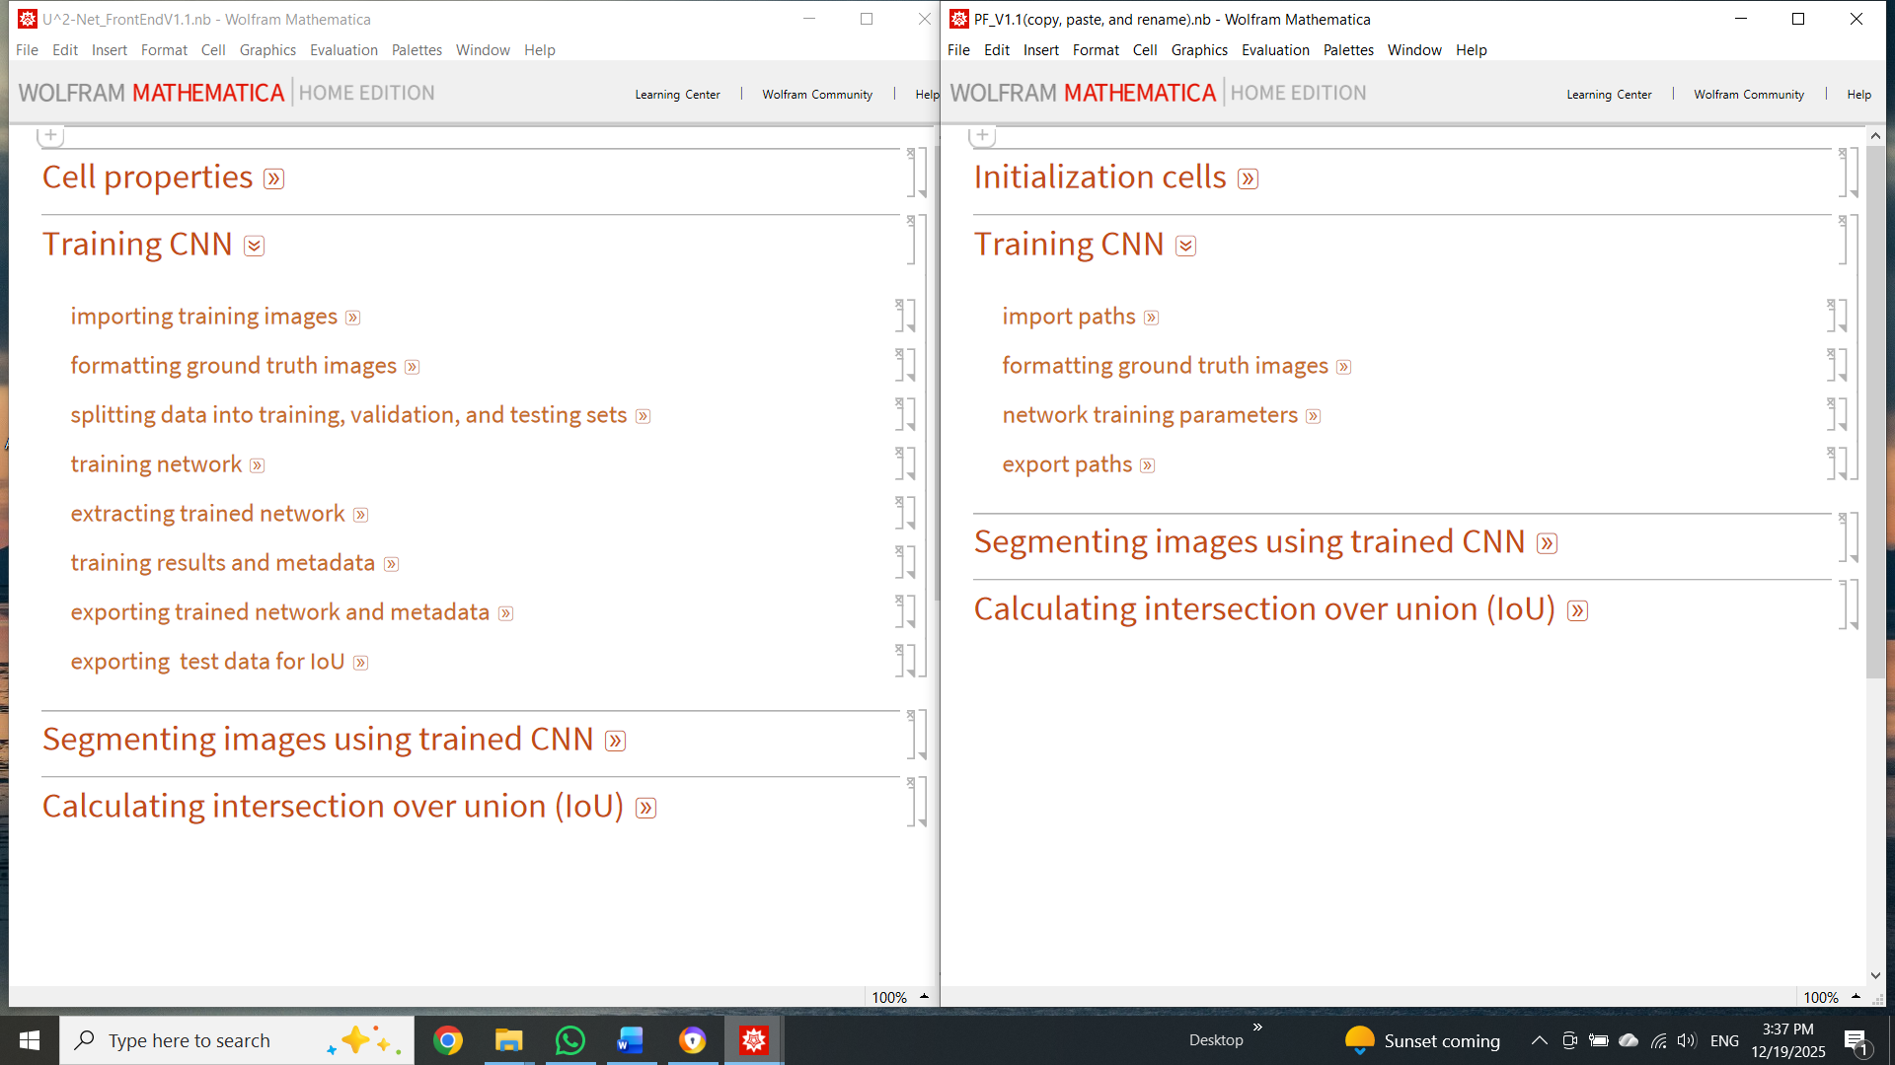

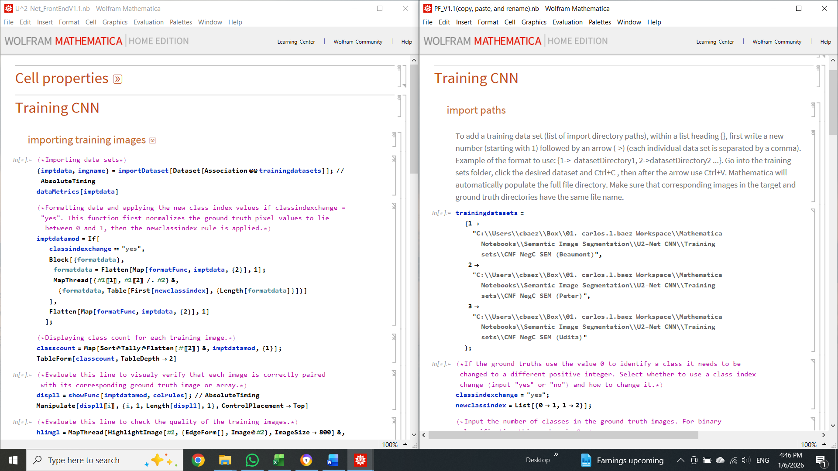
- In binary classification, the imported ground-truth images have pixel values of 0 or 255. To train the CNN, each class must be represented by a unique positive integer (zero is not allowed). In this case set classindexchange = “yes”, newclassindex = List[{0->1, 1->2}]; and numofclasses = 2;. Next, evaluate all lines within importing training images subsection. Here, all training images from the training datasets are imported and displayed.
- Next, in the formatting ground truth images subsection, evaluate inputdims. Select a network image input dimension from the list and enter the number in the variable netinputdim located in the parameter file. This value is user-selected and depends on the computer's available VRAM. For example, if available VRAM is 4 GB, select a number near 100, and if VRAM is 24 GB, select a number between 500 and 700. More VRAM allows the CNN to be trained on larger subimages.
- Then, select the fractions used to split the training data between training, validation, and test sets. Evaluate the remaining lines in the formatting ground-truth images from the parameter file, then in the front end.
- Evaluate all lines in the network training parameters. Here, the user can either import a previously trained network for continued training or start over with an untrained network. Select the total number of training rounds and the training batch size. Then, add corresponding export paths for the trained network, training metadata, and test data.
- Once all relevant variables are entered and evaluated in the parameter file, finish by evaluating the following front-end subsections:
  - splitting data into training, validation, and testing sets
  - training network
  - extracting trained network
  - training results and metadata
  - exporting trained network and metadata
  - exporting test data for IoU
- Training time is proportional to the amount of training data used and the number of training rounds, and inversely proportional to the training batch size. In practice, training time can go from a few hours to days, depending on the selected parameters.
- This newly trained (and hopefully more capable) network can be imported in the next section, Segmenting images using trained CNN, and used to segment a batch of images.

